**Faculty of Information Technology**

**Innovative Letterbox**

Group No: 06

**L.K.S.Wickramasinghe 215566P**

H.G.T.Abeywickrama 215503X

W.W.A.H.H.Fernando 215523H

E.A.K.D.Elpitiya 215521B

M.B.C.U.Marasinghe 215537E

Supervisor’s Name: Mrs.Akilani Wijethunga Date of Submission: 30/09/2022

Lecturer

Dept. Of Information Technology.

Mr.Prasanga Madushan

Lecturer

Dept. Of Information Technology

Signature of Supervisor:

**Contents**

Introduction 1

Problem in Brief 1

Aim & Objectives 2

Proposed Solution 3

Resource Requirement 5

Reference 5

Block Diagram 6

Appendix 01 7

Appendix 02 8

Introduction

With the development of technology, people rarely communicate through the mail and also, since people lead a hectic lifestyle, they tend to forget to check the mailbox. Though the technology is advanced, there are some situations where postal mail is used to deliver critical information, such as current balance statements and fixed deposit renewal letters, examination admissions (GCE O/L, GCE A/Ls), and telephone bills. In addition, even though water and light bills are not sent through postal mail, those bills are left in the mailbox. Therefore, the correspondence must be kept safe, which is not capable of a standard mailbox.

Nowadays, delivery services are widely provided by many stores. With that, the goods can be delivered to the customer's doorstep. Sometimes, the customer might not be at home when the delivery arrives. In such situations, the items are left at the doorstep, which is exposed to the outside. That could lead to the things getting soaked in if it rains or can get stolen or damaged. And also, the customer could be unaware of whether the item has been delivered or not

Problem in Brief

The mailboxes people generally have at home don't provide the facility of keeping the mail safely. Anyone can open the mailbox and take out the mail. Additionally, it doesn't offer the facility of keeping the delivered items safely.

⦁ The person might be unaware whether they have received a mail.

⦁ The mail that is left in the mailbox can get soaked in if it rains or can get stolen.

⦁ The delivered items are left at the doorstep, which can be easily stolen and damaged.

⦁ Since the mailboxes generally used don't provide security to the mail, they can be lost

or misplaced.

⦁ Unaware of when the mail or the delivered item has been delivered.

Aim & Objectives

Elevate the mailbox to the modern-day with a more secure system to protect mail from thieves and save the mail quality. Ensure most important mails are delivered on time by informing the householder.

**Objectives:**

* Alert the user when a thief tries to break the mailbox.
* Notify the user, If the mailbox is fallen.
* Fingerprint to open the mailbox and backup keypad to enter the pin
* Lock the mailbox after the parcel was placed.
* Lock and unlock the mailbox by a text message.

* Select the category of the mail.
* Instruction to input the mail one by one.
* Alert the user when receiving a mail.
* Count the number of letters in the mailbox.
* Display whether the mailbox is full or not.
* Separate section to place parcels and Lock the door after a parcel is placed.

* Notify the user in case there is water leakage inside the mailbox and cover the mail over a protective layer.

Proposed Solution

This system has a keypad, Ultrasonic Sensors, Weight Sensor Module, RTC Module, GSM Module, Rain Sensor Module, IR sensor, Light Sensor Module, Shock Sensor, Tilt Sensor, and Fingerprint Sensor as inputs.

The functionalities of the system:

* This mailbox has a security alert system when a thief tries to break the mailbox. In this case, if the door of the mailbox is force opened (open without fingerprint or password authentication) mailbox will buzz an alarm and send a message to the user through the GSM module.
* When opening the mailbox for receiving the mail, it must be only accessible to the user. therefore the user can unlock it by scanning the fingerprint or entering a password through a keypad.
* When receiving parcels delivery person can open the lid of the parcel storing container without any authentication method. After storing the parcel weight sensor detects the presence of a parcel. Then once the lid is closed, it locks until the user unlocks it using of GSM module.
* This mailbox includes a tilt sensor and a Vibration sensor and a Tilt sensor. These sensors help to identify whether the mailbox is fallen down or not. If it’s fallen down the mailbox will send a msg to the user. A vibration sensor is used to Identify if a thief tries to break the mailbox by punching it.
* When inserting a letter into the mailbox, a related category should be selected through a keypad. ( as registered or non-registered post, etc..)If the registered post is selected system will inform the user that a signature is required to take the mail.
* Mailbox Use a roller mechanism to input mail one at a time and display instructions to input mail one by one on the display that the mailbox has.
* When the mail is dropped into the box. By a message, the user will be informed and also gives the mail count. The mail count is taken by the IR sensor. Furthermore, an Ultrasonic sensor is used to identify whether the mailbox is full. If so display that the mailbox is full and inform the user.
* GSM module is used throughout the project to communicate with the user's mobile phone.
* On rainy days there’s a possible chance of leaking water inside the mail and parcel box. If leakage occurs rain sensors in the bottom of the container detect it and send a message to the user.
* Display on the mailbox will show the address and when a person comes near the mailbox it will display the instructions.

Resource Requirement

Atmega32 Microcontroller - 500 LKR

GSM Module - 2500 LKR

HX711 Weight Sensor Module - 350 LKR

Membrane Keypad - 875 LKR

16x4 LCD Display - 840 LKR

HL-83 Rain Sensor Module - 280 LKR

Fingerprint Sensor Module - 3500 LKR

IR Sensor Module - 220 LKR

HC-SR04 Ultrasonic Sensor Module - 500 LKR

Vibration Sensor - 220 LKR

Light Sensor Module - 230 LKR

Precision RTC Module - 270 LKR

12V 2000mAh Li-Po Battery - 1700 LKR

Tilt Sensor - 220 LKR

Atmel Studio

Estimated Cost - 12205 LKR

Reference

1. <https://scionelectronics.com/>
2. <https://microchip.lk/>
3. <http://www.senith.lk/>
4. [https://tronic.lk](https://tronic.lk/)/

Block Diagram

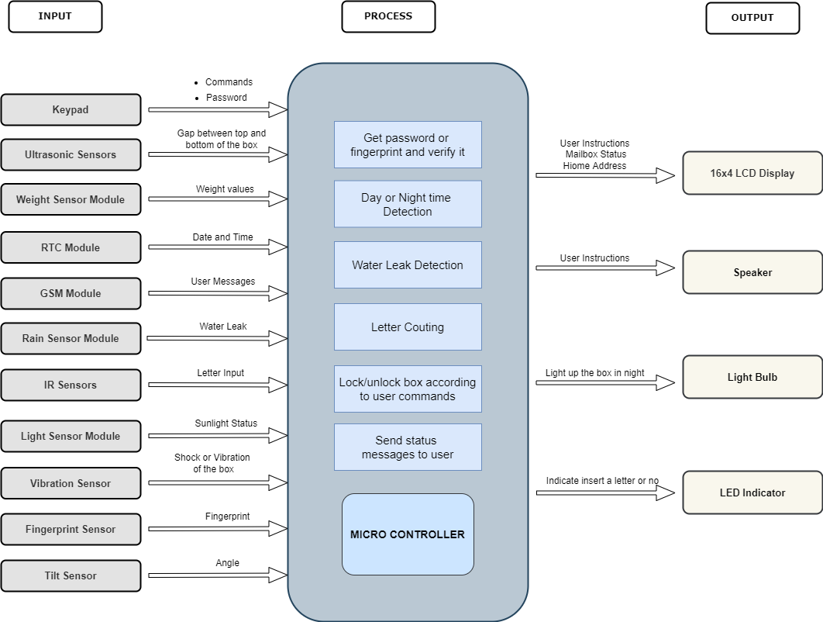

Appendix 01

|  |  |  |  |  |  |
| --- | --- | --- | --- | --- | --- |
| **Group Member** | **Name** | **Task** | **Duration** | **Start Date** | **End date** |
| Preparation Time | | | **2 weeks** | **2022.10.09** | **2022.10.22** |
| Simulation Time | | | **4 weeks** | **2022.10.23** | **2022.11.20** |
| 215503X | H.G.T.Abeywickrama | RTC Module  IR Sensor  keypad | **16 weeks** | **2022.11.20** | **2023.03.22** |
| 215523H | W.W.A.H.H.Fernando | GSM Module  Display  Vibration Sensor | **16 weeks** | **2022.11.20** | **2023.03.22** |
| 215521B | E.A.K.D.Elpitiya | Ultrasonic Sensor  Rain Sensor  Rain cover  Speaker | **16 weeks** | **2022.11.20** | **2023.03.22** |
| 215537E | M.B.C.U.Marasinghe | Fingerprint Sensor  Light Sensor  Light bulb | **16 weeks** | **2022.11.20** | **2023.03.22** |
| 215566P | L.K.S.Wickramsinghe | Weight Sensor  Locking mechanism  Tilt Sensor | **16 weeks** | **2022.11.20** | **2023.03.22** |
| Assemble Modules and Sensors ,  Testing And Bug Fixing | | | **14 weeks** | **2023.03.23** | **2023.06.29** |
| Simulation Time | | | **6 weeks** | **2023.06.30** | **2023.08.09** |

Appendix 02

